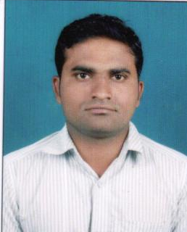
CURRICULUM VITAE

M.NARESH
H.NO T2-836,TILAKNAGADOWN,
GODAVARIKHANI,
KARIMNAGAR-505209.
PH:8978675523
Email:naresh.m8978@ gmail.com

OBJECTIVE
I look forward to associate with an organisation where there is a scope for contributing and upgrading my knowledge for development of both self and Organisation. I strive to reach excellent position in my areas of interest up to the expectation of my superiors.

EDUCATIONAL QUALIFICATIONS
- MBA (Marketing &Finance) through Sri Chakra Institute Of Computer Sciences,Sheriguda,Hyderabad With 65% In 2011.
- Graduation (B.Com) through Government Degree College, Godavarikhani, Kakatiya University, Karimnagar With 64% In 2008.
- Intermediate (C.E.C) through Sai Geethanjali Junior college from Board of Intermediate Education, Godavarikhani With 77.3%In 2005.
- Secondary School through Singareni Collaries Company Ltd from Board of Secondary Education,Godavarikhani With 72%In 2003.

EXPERIENCE
I Have One Year Eight Months An Experiance in SHRIRAM TRANSPORT FINANCE COMPANY LTD AS A PRODUCT EXECUTIVE IN MIRYALAGUDA IN NALGONDA.
I Have Eight Months An Experience As a Vehicle Finance ExecUtive In Meghana Associates In Karimnagar.
I Have WORKED AN EXPERIENCE in Shriram City Union Finance Limited As A Executive Since 09 Months.
SELF ASSESSMENT
- Motivated and Self Driven
- Good at Listening skills
- Good Analytical Skills
- Enthusiastic Team player

TECHNICAL SKILLS

- MS Office.PG DCA
- Internet Concepts

ACADEMIC PROJECT

Submitted project “A Study on” INVENTORY AND STORES MANAGEMANT during fourth semester of MBA, done KESORAM CEMENT INDUSTRIES LTD.

PERSONAL DETAILS

Name : M.NARESH
Father’s Name : NAGULU
Date of Birth : 27th JUN 1987
Gender : Male
Religion : Hindu
Nationality : Indian
Marital Status : Married
Languages Known : English, Telugu

DECLARATION

I hereby declare that all the information provided by me in this application is factual and correct to the best of my Knowledge and belief.

Place: GODAVARIKHANI
Date:
(M.NARESH)

